# **First Prototype**

## **Login and Sign Up**

Users can sign up with an email address, Google or Facebook account, and then they have to log in with an email address and password.

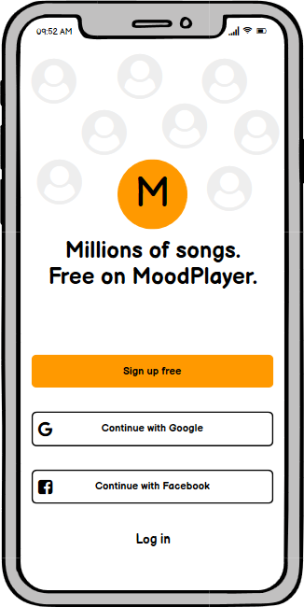

Figure 1:Sign up and login page

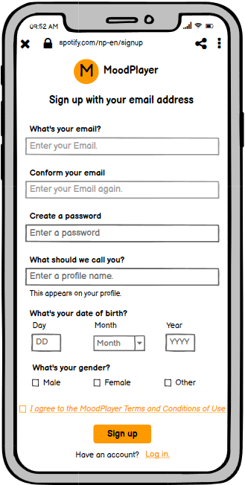

Figure 2: Sign up with Email Address

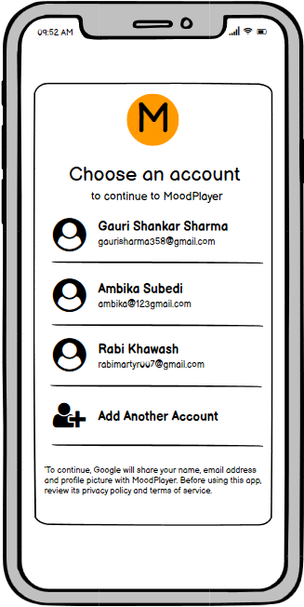

Figure 3:Sign up with a google account

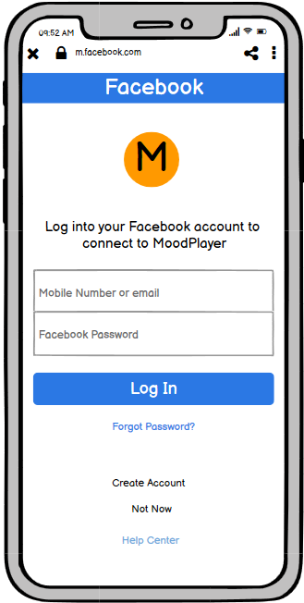

Figure 4:Sign up with a Facebook account

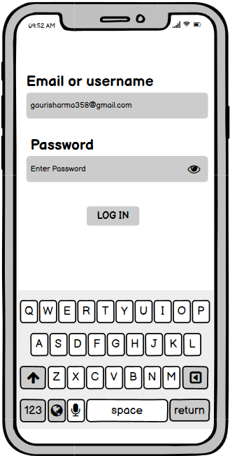

Figure 5:Login page

## **Home**

Users can view and play songs from their previous activities, play songs from playlists generated by MoodPlayer.

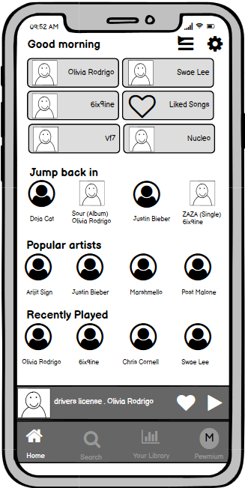

Queue page button

Setting page button

List of artists followed by the user

Song that was played last time

Figure 6:Home page

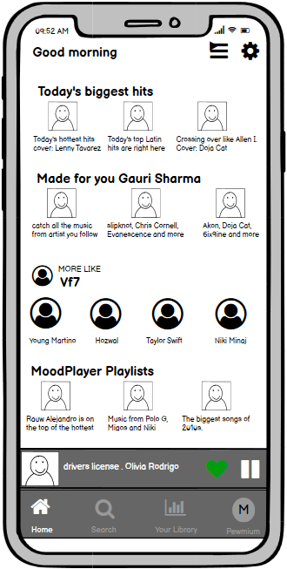

MoodPlayer’s playlists

Like button

Figure 7: Home Page

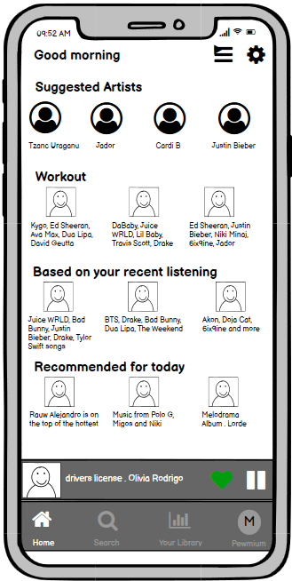

MoodPlayer’s playlists

Figure 8:Home page

## **Being Played Song’s Interface**

Only premium users will be able to download songs and view song’s lyrics and videos.

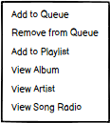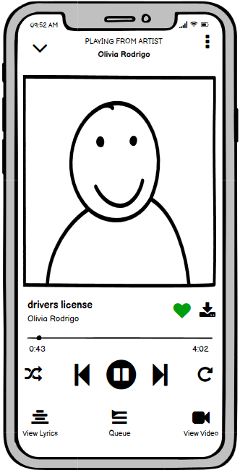

Shuffle button

Song download button

Song repeats option button

Figure 9:Being played song’s interface

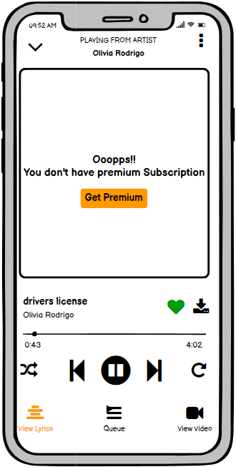

Premium page button

Figure 10: Viewing lyrics on the free version

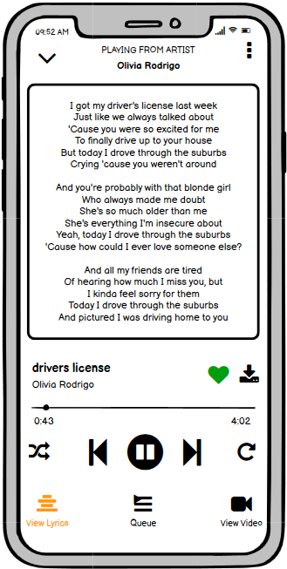

Song’s lyrics

Figure 11: Viewing lyrics on the premium version

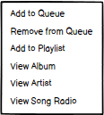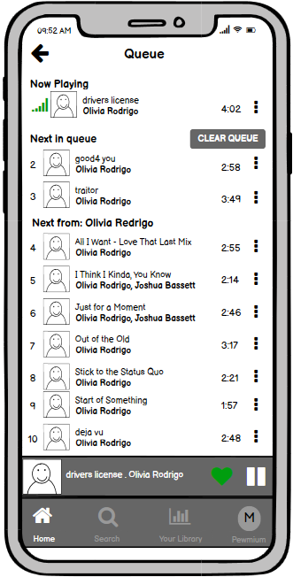

Figure 12: Queue page where songs can be added and removed from the queue

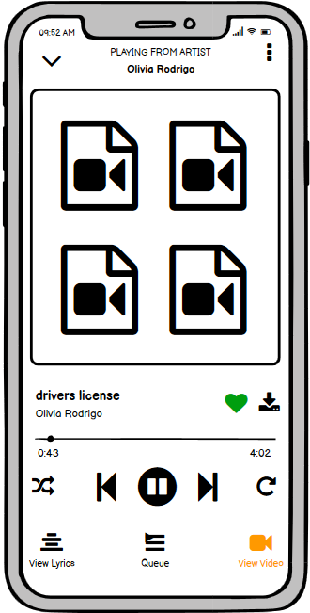

Song’s video

Figure 13: Viewing video of a song in the premium version

## **Search**

Users can search according to their input or they can directly go through different genres.

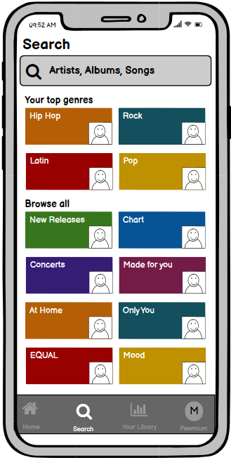

Song’s genres list

Search songs by name of artists or albums or songs

Figure 14: Search Page

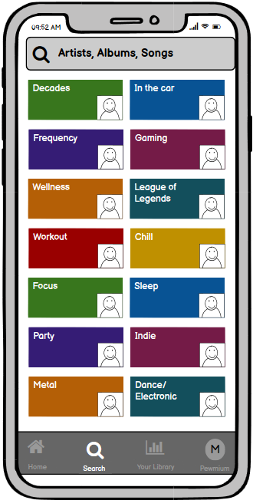

Figure 15:Search page

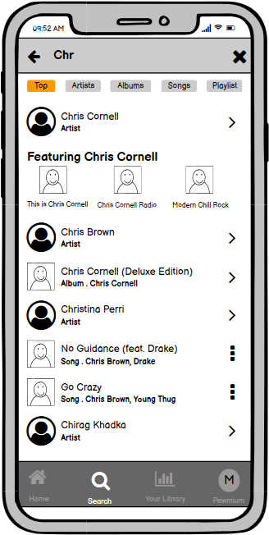

Found artists, albums, songs matched by searched character fields

Filter options for results

Searching artist “Chris Cornell”

Figure 16: Searched result page

## **Artist**

Users can view artist’s popular songs and albums, their albums, featured tracks, playlists, biography, and other artists like by the current artist’s fans.

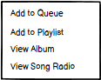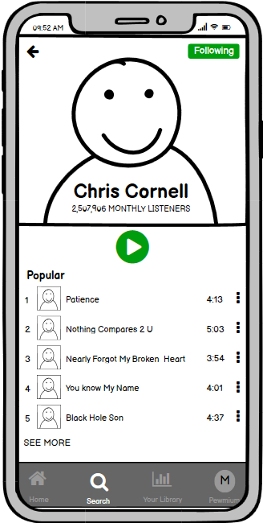

Artist profile picture

Figure 17: Artist Profile Page

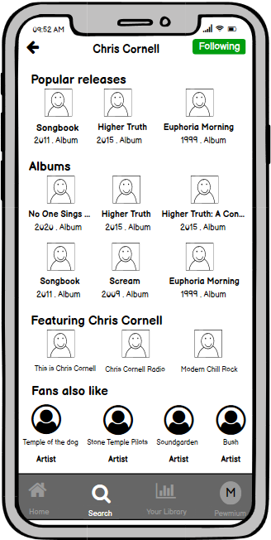

The **artist** who is a guest feature on the track/album.

Figure 18: Artist profile page

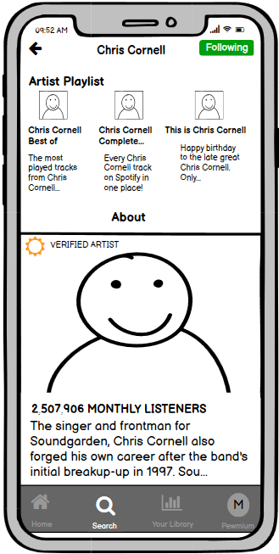

Artist short biography

Figure 19: Artist profile page

## **Album**

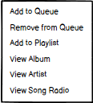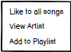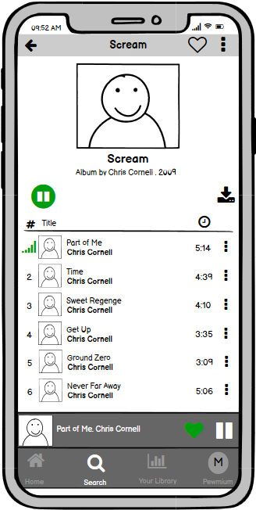

Album picture

Figure 20: Album page

## **Song’s Radio**

Radio page provides different songs from different artists that fall almost in the same genre of the song. This helps the user’s mood going on even after reaching the end of a playlilst.

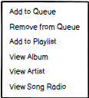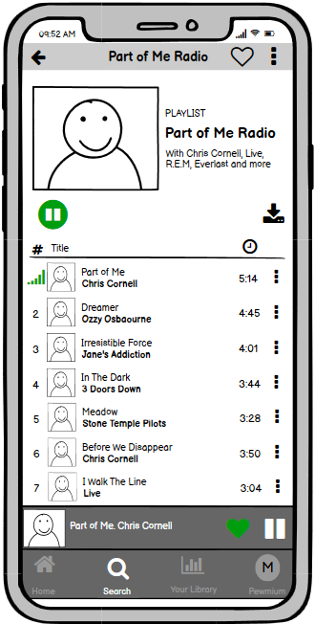

Radio picture

Figure 21: Song's radio page

## **Library**

This is the user’s activity page.

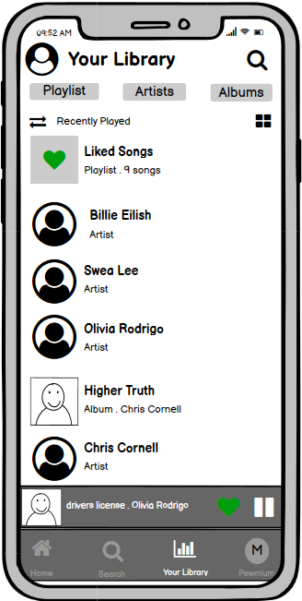

Library page filter options

View mode

Figure 22: Library Page

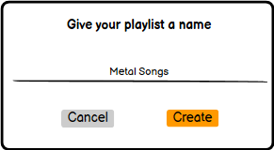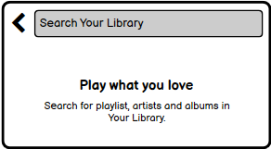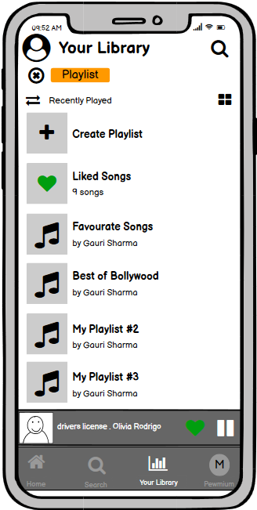

Figure 23: Library’s playlist page

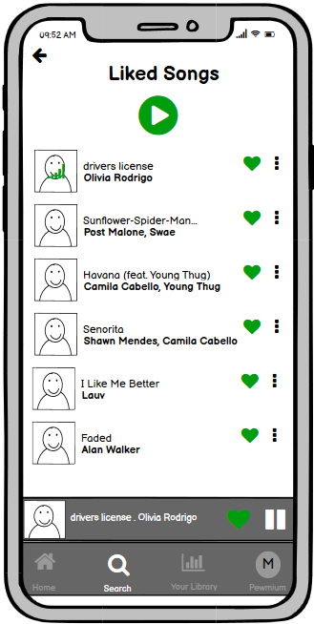

Figure 24: Liked songs of playlist from the library page

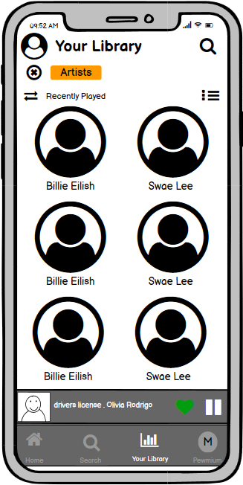

Artists followed by the user

Figure 25: Library’s artist page

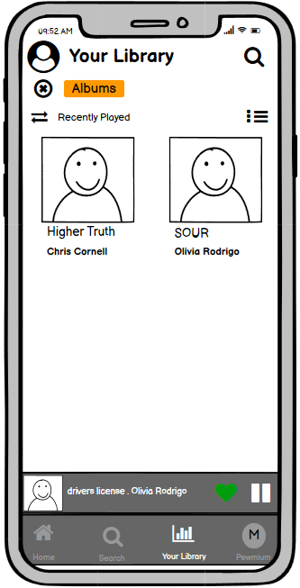

Liked albums by the user

Figure 26: Library’s album page

## **Premium**

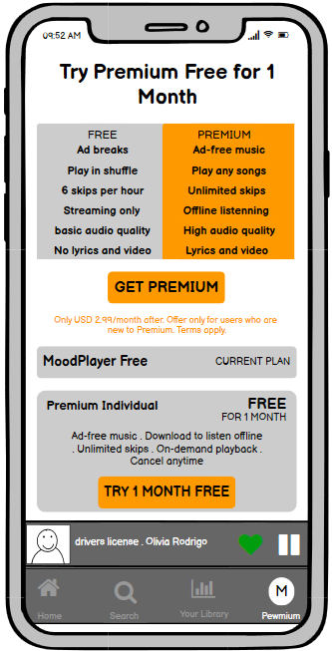

Figure 27: Premium page where users can upgrade from free to the premium version

## **Settings**

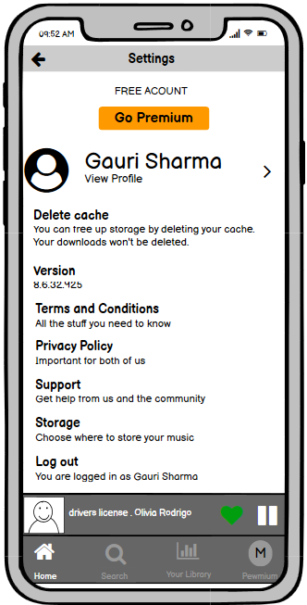

Figure 28: Settings page